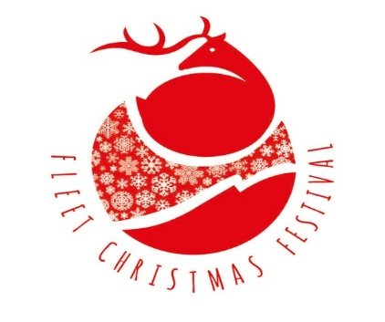
Dear Resident,
Fleet & District Christmas Festival 2021
2020 was an extraordinary year and one that, sadly, meant some of the usual Christmas celebrations had to be cancelled – one of these was the Fleet Christmas Festival. The small team of volunteers, who manage the event, are working hard to try to ensure that 2021 is not the same. We understand that Government restrictions might mean that we have to change our plans but we are optimistic and are now planning for the 2021 Fleet Christmas Festival to be held on Wednesday, 24th November, 2021. So please put the date in your diary!
Our team will be working with the support of Fleet Town Council, Hart Shopping Centre and Fleet Lions to ensure that the event goes ahead safely and responsibly. There will be the usual market stalls, along Fleet Road, selling lots of festive food and crafts, although there will be fewer than previous years to allow for social distancing. The market will be open to the public from 2 pm – 9 pm, so please do come along to get your Christmas shopping started.
In addition to the Market, Fleet Town Council will again be organising the annual Christmas Lights Switch On, carol singing and all the entertainment in Gurkha Square and Hart Shopping Centre will be welcoming their shoppers back for the festive season with a free glass wine and mince pie! So, lots to do and lots of fun to be had for all the family!
As in previous years, in order to get all the stalls and activities in place, Fleet Road will be closed to traffic from The Oatsheaf roundabout to Church Road from 11.00 a.m. until 11.00 p.m. on the 24th November.
We will be doing all we can to minimise any inconvenience to you and clearly marked diversion signs will be in place to manage traffic throughout the event. However, if you have any concerns, please contact Mike Collen at mike.collen@Fleetlions.org.uk or Sue Tilley at sue.tilley@ntlworld.com.
We do hope that you will come along and enjoy everything that the Festival will be offering and look forward to welcoming you on the 24th.
Yours sincerely,

The Volunteer Organisers of the Fleet Christmas Festival 2021
www.fleetchristmasfestival.org

